**Project on**

**Travel Management System**

**Submitted by**

PIJUSH MAZUMDER

162410014

SALAH UDDIN AHMED

172400035

RAHMAT ULLAH

191400080

in partial fulfilment of the requirement for the degree of Bachelor of Science in Computer

Science and Engineering



Department of Computer Science and Engineering

Faculty of Engineering and Technology

Eastern University

July 2023

**Declaration**

We hereby declare that the work is being presented in this project entitled **“Travel Management System”** in partial fulfilment of the requirement for the degree of Bachelor of Science in Computer Science and Engineering under the faculty of ­­Engineering and Technology, Eastern University, Bangladesh is an authentic record of our own work carried out under the supervision of **Muhammad Mahfuz Hasan.** It is also declared neither this report nor any part of it has been submitted elsewhere for the award of any kind of degree.

**Pijush Mazumder**

**Salah Uddin Ahmed**

**Rahmat Ullah**

**Approval**

The project titled “**Travel Management System**” submitted by **Pijush Mazumder (162410014), Salah Uddin Ahmed (172400035), Rahmat Ullah (191400080)** has been accepted satisfactorily in partial fulfilment of the requirement for the degree of Bachelor of Science in Computer Science and Engineering.

**Board of Examiners**

|  |  |  |
| --- | --- | --- |
| **Muhammad Mahfuz Hasan** |  |  |
| Associate Professor and Chairperson  Department of Computer Science and Engineering  Eastern University |  | Chairman  (Supervisor) |

|  |  |  |
| --- | --- | --- |
| **Prof. Dr. Md. Mahfuzur Rahman** |  |  |
| Dean, Faculty of Engineering and Technology  Eastern University |  | Member  (Ex-Officio) |

|  |  |  |
| --- | --- | --- |
| **Mousumi Bala** |  |  |
| Assistant Professor  Department of Computer Science and Engineering  Eastern University |  | Member |

|  |  |  |
| --- | --- | --- |
| **Tanzim Tamanna Shitu** |  |  |
| Lecturer  Department of Computer Science and Engineering  Eastern University |  | Member |

**Acknowledgement**

This project has been supervised by Muhammad Mahfuz Hasan, Associate Professor and Chairperson, Department of Computer Science and Engineering, Eastern University, Bangladesh. We are very much grateful and indebted to him for the kind suggestions, guidance, instructions, and overall supervision that he offered us during our project investigation. We also thank him for reviewing the preliminary versions of this project, making useful corrections, and providing suggestions. We would also like to express our gratitude to our parents and teachers for bringing us up where we are today. We are thankful to the Department of Computer Science and Engineering, Eastern University for providing us with an excellent educational environment and computing facility. We also offer our best regards Eastern University administration, and all other esteemed teachers of the department for their affectionate feelings and encouragement throughout the period of our project work. Finally, warm thanks to all of our well-wishers and friends for moral support and inspiration.

**Abstract**

The rapid progress of technological advancement has transformed the way we plan and manage travel. In this era of seamless connectivity, there is a growing need for an efficient Travel Management System (TMS) that encourages diverse requirements for travelers. This project aims to develop a comprehensive but simple TMS to streamline and enhance the travel experience.

The Travel Management System is designed to automate various aspects of travel planning, booking, and organization. It encloses features such as itinerary or route management, online ticket reservation, accommodation booking, expense tracking, and real-time updates on travel-related information. By leveraging cutting-edge technologies, the system aims to provide users with a user-friendly interface, ensuring a hassle-free travel experience.

Furthermore, the project focuses on integrating key functionalities, including route optimization, travel alerts and notifications, travel documentation management, and personalized recommendations based on user preferences. Through collaboration with airlines, hotels, and other travel service providers, the system aims to offer an extensive database of options, ensuring travelers have access to a wide range of choices tailored to their needs.

The project team will employ agile software development methodologies to ensure iterative development, allowing for regular feedback and enhancements. Extensive testing and user validation will be conducted to ensure the reliability, security, and usability of the Travel Management System.

By developing a robust and user-friendly Travel Management System, this project seeks to revolutionize the way travelers plan and manage their journeys. It aspires to provide an all-in-one solution that simplifies the travel process, enhances efficiency, and delivers an unparalleled travel experience.

**Table of Content**

|  |  |  |  |
| --- | --- | --- | --- |
| **Content** | | | **Page** |
| Abstract ------------------------------------------------------------------------------------------- | | | vi |
| List of Figures ----------------------------------------------------------------------------------- | | | vii |
|  | | | |
| **Chapter 1: Introduction** | | | **1-3** |
| 1.1 | Introduction --------------------------------------------------------------------------- | | 1 |
| 1.2 | Motivation ---------------------------------------------------------------------------- | | 2 |
| 1.3 | Objective ------------------------------------------------------------------------------ | | 2 |
| 1.4 | Project Schedule --------------------------------------------------------------------- | | 3 |
| 1.5 | Expected Outcome ------------------------------------------------------------------ | | 3 |
|  |  | |  |
| **Chapter 2: Literature Review** | | | **4** |
| 2.1 | Introduction -------------------------------------------------------------------------- | | 4 |
| 2.2 | Comparative Studies ---------------------------------------------------------------- | | 4 |
|  |  | |  |
| **Chapter 3: Problem Statement** | | | **5** |
|  | | |  |
| **Chapter 4: System Design and Analysis** | | | **6-12** |
| 4.1 | Introduction -------------------------------------------------------------------------- | | 6 |
| 4.2 | Use Case Modelling and Description -------------------------------------------- | | 6 |
|  | 4.2.1 | Use Case 1: User Registration ----------------------------------------- | 6 |
|  | 4.2.2 | Use Case 2: Trip Planning and Recommendations ------------------ | 6 |
|  | 4.2.3 | Use Case 3: Booking Management ------------------------------------ | 7 |
| 4.3 | Methodology ------------------------------------------------------------------------- | | 8 |
| 4.4 | ER Diagram -------------------------------------------------------------------------- | | 9 |
| 4.5 | Data Flow Diagram ----------------------------------------------------------------- | | 9 |
|  | 4.5.1 | Data Flow Diagram Level 0 -------------------------------------------- | 9 |
|  | 4.5.2 | Data Flow Diagram Level 1 -------------------------------------------- | 10 |
| 4.6 | The proposed main features of the Project | | 10 |
|  | 4.6.1 | User Features ------------------------------------------------------------- | 10 |
|  | 4.6.2 | Administrator Features -------------------------------------------------- | 10 |
| 4.7 | Project Management Life Cycle -------------------------------------------------- | | 11 |
| 4.8 | Challenges --------------------------------------------------------------------------- | | 12 |
|  | | | |
| **Chapter 5: Implementation and Testing** | | | **13-17** |
| 5.1 | Introduction --------------------------------------------------------------------------- | | 13 |
| 5.2 | Implementation of Database -------------------------------------------------------- | | 13 |
| 5.3 | Implementation of Front-end Design ---------------------------------------------- | | 14 |
|  | 5.3.1 | Language and Framework ---------------------------------------------- | 14 |
| 5.4 | Implementation of Back-end Development ------------------------------------- | | 15 |
| 5.5 | Snapshot of Front-end -------------------------------------------------------------- | | 16 |
|  | 5.1.1 | Home Page --------------------------------------------------------------- | 16 |
|  | 5.1.2 | Login Page --------------------------------------------------------------- | 17 |

|  |  |  |  |
| --- | --- | --- | --- |
| **Chapter 6: Conclusion and Future Works** | | | **18-18** |
|  | 6.1 | Conclusion ---------------------------------------------------------------- | 18 |
|  | 6.2 | Future Work -------------------------------------------------------------- | 18 |
| **References** ------------------------------------------------------------------------------------- | | | 19 |

**List of Figures**

|  |  |  |
| --- | --- | --- |
| **Figure No.** | **Figure Name** | **Page** |
| Fig 4.2 | Use Case Diagram ------------------------------------------------------ | 7 |
| Fig 4.4 | ER Diagram ------------------------------------------------------------- | 9 |
| Fig 4.5.1 | Data Flow Diagram Level 0 ------------------------------------------ | 9 |
| Fig 4.5.2 | Data Flow Diagram Level 1 ------------------------------------------ | 10 |
| **Fig 4.7** | **Project Development Life Cycle -------------------------------------** | 12 |
| Fig 5.2 | Database Tables **--------------------------------------------------------** | 14 |
| Fig 5.1.1 | Home Page -------------------------------------------------------------- | 16 |
| Fig 5.1.2 | Login Page -------------------------------------------------------------- | 17 |

**Chapter 1**

**Introduction**

* 1. **Introduction**

The travel industry is experiencing remarkable growth, particularly in the context of Bangladesh, a developing country located in South Asia. With a population almost exceeding 180 million, Bangladesh is witnessing a significant surge in travel and tourism. In this dynamic environment, the implementation of an efficient and technologically advanced Travel Management System (TMS) holds immense potential for streamlining travel processes and enhancing the travel experience.

In Bangladesh, where social life is increasingly being modernized through the integration of information technology, the need for an effective Travel Management System has become apparent. The system's primary objective is to address the challenges faced by travelers in accessing necessary travel information and services. By leveraging technology and digital connectivity, the Travel Management System caters to the specific needs of the Bangladeshi population, facilitating efficient travel planning, bookings, and management.

Bangladesh's position in the South Asian region further emphasizes the importance of a comprehensive Travel Management System. With its geographical proximity to neighboring countries, such as India, Nepal, and Bhutan, Bangladesh serves as a crucial gateway for travelers exploring South Asia. The Travel Management System not only benefits Bangladeshi travelers but also enables seamless travel arrangements for individuals visiting or transiting through the country.

Demographically, the Travel Management System targets a diverse range of users in Bangladesh, including business professionals, leisure travelers, and tourists. For corporate travelers, the system offers a centralized platform to manage itineraries, streamline bookings, and track expenses, ensuring hassle-free business travel experiences. Leisure travelers and tourists benefit from the system's ability to provide detailed information on local attractions, accommodations, transportation options, and cultural experiences.

Academic research and development in the field of travel management systems have tied the way for innovative features that cater to the specific needs of the Bangladeshi travel landscape. Integration with emerging technologies, such as mobile applications, geolocation services, and e-payment systems, enhances convenience, accessibility, and safety for travelers navigating Bangladesh's diverse terrain.

In conclusion, the implementation of a robust Travel Management System in Bangladesh holds immense potential for transforming travel experiences and supporting the growth of the country's travel industry. By addressing the unique requirements of the Bangladeshi population and its position within the South Asian region, the system contributes to the promotion of efficient and seamless travel, facilitating the exploration of Bangladesh and its neighboring countries.

* 1. **Motivation**

The growing complexities and demands of modern travel require a robust and efficient Travel Management System (TMS). With the rapid growth of the travel industry, individuals and organizations face challenges in managing itineraries, bookings, and expenses. The motivation behind developing a TMS in Bangladesh lies in the need to streamline travel processes, enhance user experiences, and optimize cost control. By leveraging advanced technologies and integrating various functionalities, the TMS aims to provide a centralized platform for travelers, offering convenience, personalized recommendations, and improved efficiency. This motivation drives the development of a comprehensive TMS tailored to the specific requirements of the travel landscape in Bangladesh.

* 1. **Objectives**

The objective of our project is to revolutionize the way travel is planned and managed in Bangladesh by implementing a comprehensive Travel Management System (TMS). Our aim is to provide a user-friendly platform that simplifies the travel process and enhances the overall travel experience for individuals and organizations.

Through the TMS, we seek to streamline travel arrangements, from itinerary planning to booking accommodations and transportation. By integrating advanced technologies and data analytics, our objective is to optimize travel routes, provide real-time updates on travel-related information, and offer personalized recommendations based on user preferences.

Furthermore, we strive to enhance cost control and expense management by providing users with tools to track and analyze their travel expenses. Our objective is to enable organizations to make informed decisions regarding travel budgets, policies, and vendor selection.

By developing the Travel Management System, our objective is to contribute to the growth of the travel industry in Bangladesh and promote seamless travel experiences. We aim to empower individuals, enhance efficiency, and foster a positive impact on the overall travel landscape in the country.

* 1. **Project Schedule**

|  |  |  |
| --- | --- | --- |
| **Activities** | **Duration (in Week)** | **Total week** |
| Brainstorming | Week 1, Week 2, | 2 |
| Problem dentification | Week 3, Week 4, Week 5 | 3 |
| System Analysis | Week 6, Week 7 | 2 |
| System Design | Week 8, Week 9, Week 10 | 3 |
| Database Design | Week 11, Week 12, Week 13 | 3 |
| Front-end Design | Week 14, Week 15 | 2 |
| Backend Development and Database Connection | Week 16, Week 17, Week 18 | 3 |
| Bug hunting and fixing | Week 19, Week 20, Week 21 | 3 |

**Table 1.4 Project Schedule**

* 1. **Expected Outcome**

The Travel Management System aims to deliver a seamless and efficient travel experience, providing users with a centralized platform for streamlined travel planning, real-time updates, and personalized recommendations. The expected outcome is an optimized travel process, enhanced user satisfaction, and improved cost control for individuals and organizations.

**Chapter 2**

**Literature Review**

1. **Introduction**

This chapter provides a comprehensive review of the existing literature surrounding the development and implementation of Travel Management Systems (TMS). By examining relevant studies, we aim to gain insights into the best practices, challenges, and potential benefits associated with TMS. This review serves as a foundation for our project, ensuring informed decision-making and contributing to the advancement of the field.

**2.2 Comparative Studies**

Conducting comparative studies is crucial to assess the existing projects related to our envisioned Travel Management System. Through these studies, we analyze the platforms and approaches used in previous projects, highlighting similarities and differences. This comparative analysis provides valuable insights for our project, enabling us to build upon previous work and incorporate innovative features to meet the specific needs of our system.

**Chapter 3**

**Problem Statement**

The existing travel management processes in Bangladesh lack efficiency and fail to meet the evolving needs of travelers. Individuals and organizations face challenges in itinerary planning, booking accommodations, and managing travel expenses. Access to real-time travel information, personalized recommendations, and streamlined booking processes is limited. Furthermore, the absence of a centralized platform hinders the ability to optimize cost control and enhance overall travel experiences. Therefore, there is a critical need to develop a comprehensive Travel Management System that addresses these limitations and empowers users with efficient, user-friendly, and personalized travel management solutions.

Please note that you can customize and refine the problem statement based on the specific requirements and challenges identified in your project.

**Chapter 4**

**System Design and Analysis**

**4.1 Introduction**

The System Design and Analysis chapter presents a comprehensive overview of the proposed Travel Management System. This section introduces the key objectives, system architecture, and core functionalities, laying the foundation for the subsequent analysis and design phases.

**4.2 Use Case Modelling and Description:**

The Use Case Modeling and Description section outlines how users interact with the system to achieve specific objectives. It includes the identification of actors, their roles, and the use cases that define their interactions with the system. In the context of the Travel Management System, there are several actors involved, including Users, who access the system for registration, trip planning, and booking management. The system provides personalized recommendations for flights, accommodations, attractions, and activities based on user preferences. Users can manage their bookings and receive notifications regarding any changes or cancellations.

Please note that this simplified description summarizes the main elements of the Use Case Modeling and Description section for the "Travel Management System" project.

**4.2.1 Use Case 1: User Registration**

* **Description:** Allows users to create an account to access the system.
* **Actors:** User
* **Preconditions:** User has access to the system.
* **Basic Flow:**
  1. User accesses the registration page and provides the required information.
  2. System verifies the user's credentials and creates a unique account.
  3. User receives a confirmation email or notification.
  4. User can now log in and access the system's feature

**4.2.2 Use Case 2: Trip Planning and Recommendations**

* **Descriptio**n: Assists users in planning their trips and provides personalized recommendations.
* **Actors**: User
* **Preconditions**: User is logged in and has access to the system.
* **Basic Flow**:
  1. User enters trip details, including destination, dates, and preferences.
  2. System analyzes the information and generates personalized recommendations for flights, accommodations, attractions, and activities.
  3. User reviews the recommendations and selects preferred options.
  4. System saves the selections to the user's itinerary for future reference.

**4.2.3 Use Case 3: Booking Management**

* **Description**: Enables users to manage their bookings and reservations.
* **Actors**: User
* **Preconditions**: User is logged in and has active bookings.
* **Basic Flow**:
  1. User accesses the booking management section.
  2. User views a list of their current and upcoming bookings.
  3. User can modify or cancel existing bookings, adhering to the system's policies.
  4. User receives notifications and updates regarding their bookings, including changes or cancellations.

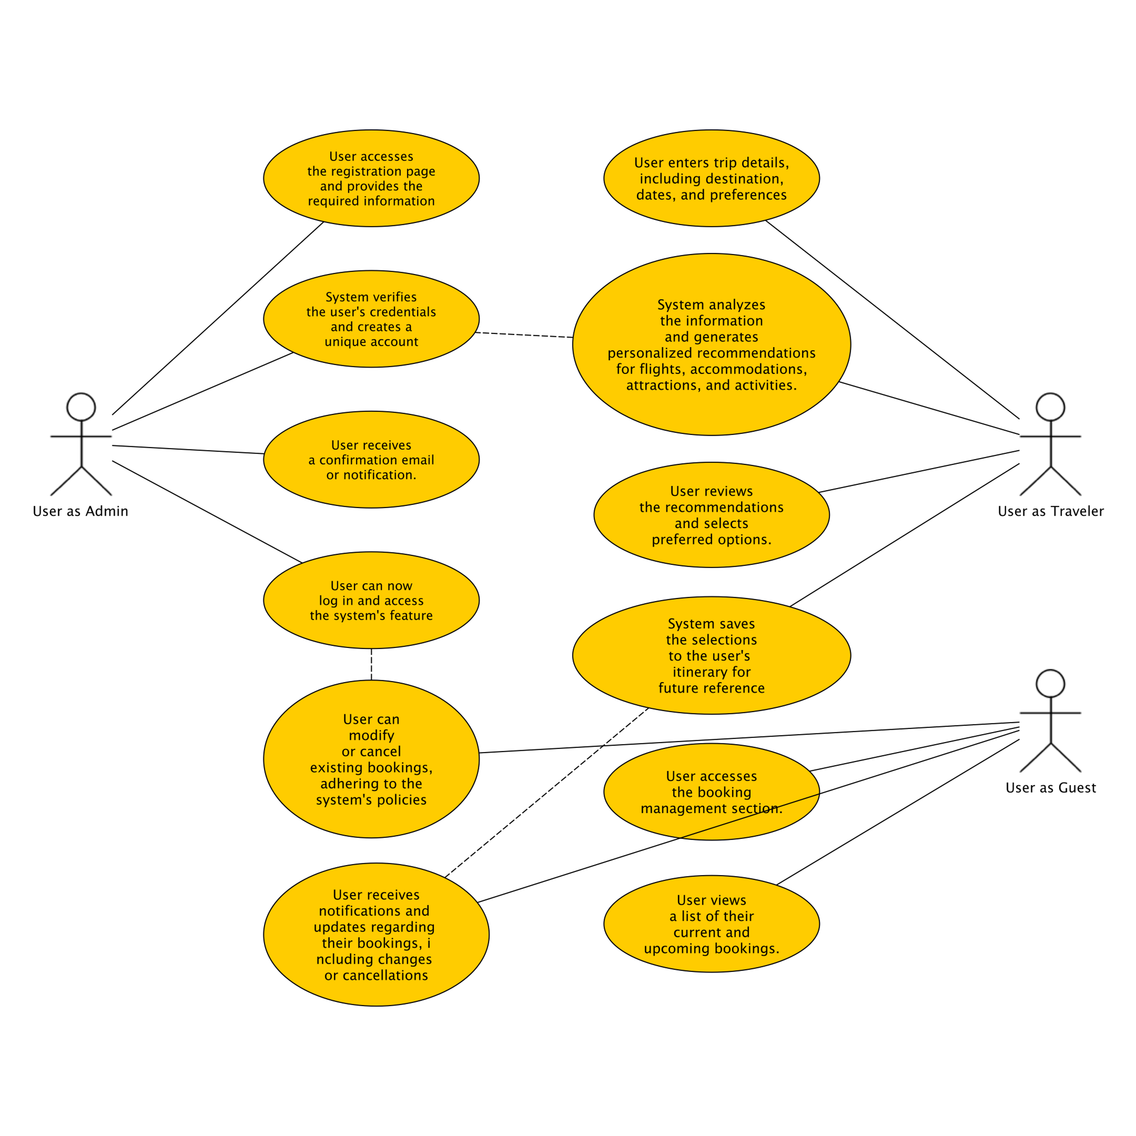

**Fig 4.2 Use Case Diagram**

**4.3 Methodology**

In order to ensure the successful development of the Travel Management System, we will adopt an agile software development methodology. Agile methodologies are known for their flexibility, adaptability, and focus on iterative development. This approach will allow us to respond to changing requirements and incorporate feedback from stakeholders throughout the development process.

The key phases of our agile methodology include:

1. **Project Planning:** Define project scope, objectives, and team roles. Create a product backlog to capture and prioritize requirements.
2. **Iterative Development:** Break the project into small iterations or sprints. Each sprint involves selecting items from the product backlog, developing, testing, and delivering a working increment of the Travel Management System.
3. **Daily Stand-ups:** Conduct brief daily meetings to discuss progress, challenges, and plan for the day. This promotes communication and collaboration among team members.
4. **Continuous Testing:** Perform ongoing testing throughout the development process to ensure quality and identify and address issues early on. This includes unit testing, integration testing, and user acceptance testing.
5. **Stakeholder Feedback and Iteration:** Gather feedback from users and stakeholders after each iteration and incorporate it into subsequent iterations. This allows for continuous improvement and ensures that the system meets the evolving needs of its users.
6. **Deployment and Release:** Once all iterations are completed and the system meets the desired level of functionality and quality, deploy the Travel Management System to the production environment.
7. **Maintenance and Support:** Provide ongoing maintenance and support for the system, addressing any issues or adding new features as required.

By following this agile methodology, we aim to deliver a high-quality Travel Management System that meets the needs of users in a timely and efficient manner. Regular feedback, collaboration, and iterative development will ensure that the system aligns with user expectations and industry best practices.

**4.4 ER Diagram**

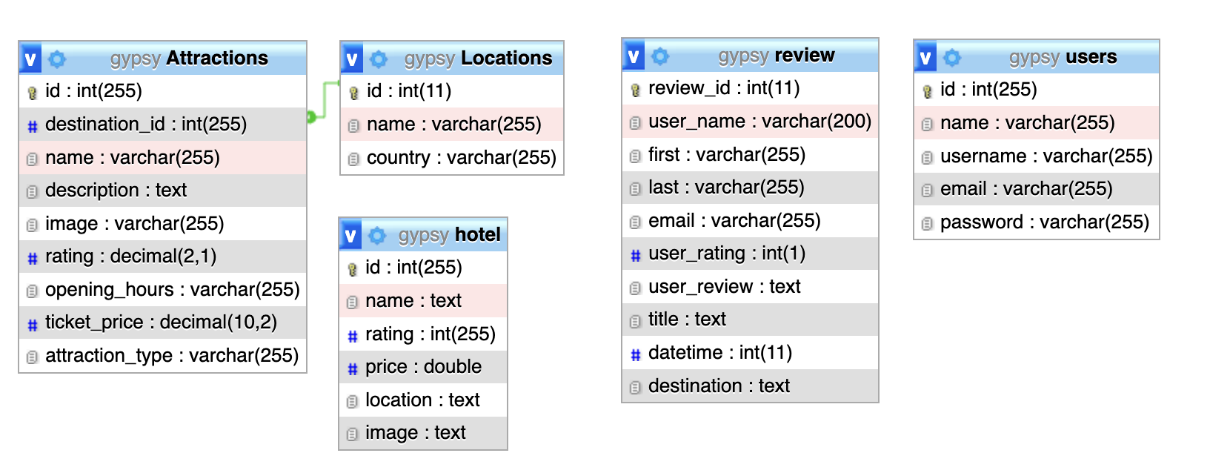

**Fig 4.4 ER Diagram**

* 1. **Data Flow Diagram**
     1. **Data Flow Diagram Level 0**

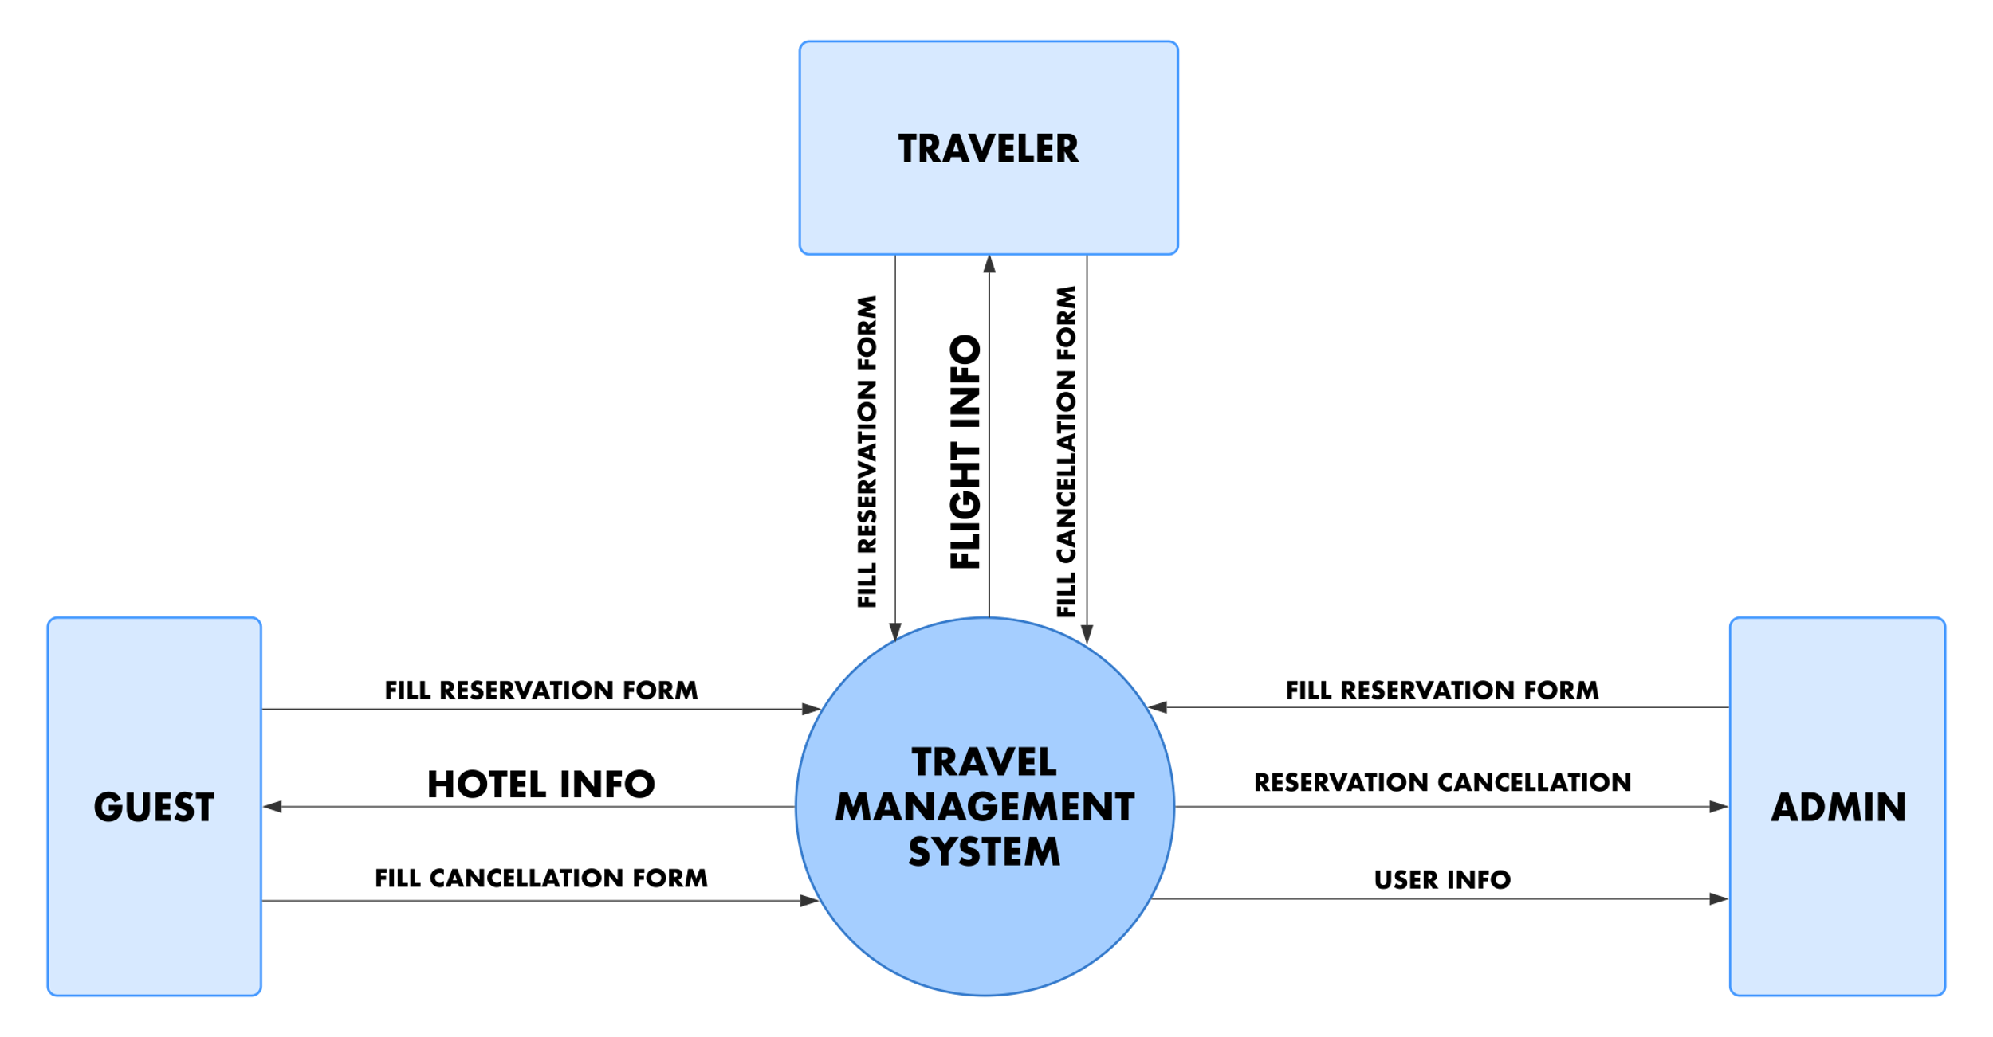

**Fig 4.5.1 Data Flow Diagram Level 0**

* + 1. **Data Flow Diagram Level 1**

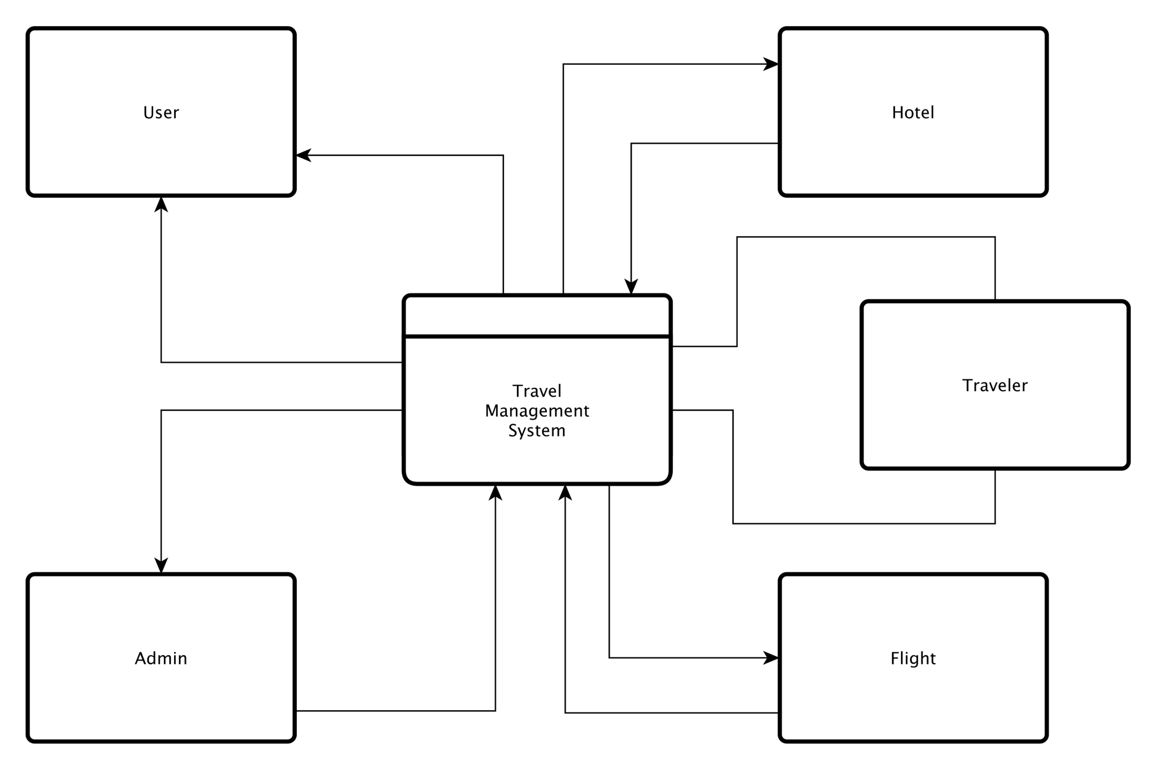

**Fig 4.5.2 Data Flow Diagram Level 1**

* 1. **The proposed main features of the Project**
     1. **User Features**
* User Registration and Login: Users can create an account and log in to access the system.
* Trip Planning and Recommendations: Users can input their travel preferences and receive personalized recommendations for flights, accommodations, attractions, and activities.
* Booking Management: Users can search, book, modify, and cancel their travel bookings.
* Review and Rating System: Users can provide feedback and ratings for the services they have used during their trips.
* Itinerary Management: Users can view and manage their trip itineraries, including details of flights, accommodations, and activities.
* Notifications and Alerts: Users receive notifications and alerts regarding booking updates, flight delays, and other important travel information.
* Customer Support: Users can access customer support for assistance and inquiries.
  + 1. **Administrator Features**
* Admin Dashboard: Administrators have access to a centralized dashboard to manage the system's operations.
* User Management: Administrators can manage user accounts, including registration, login, and account details.
* Booking Management: Administrators can oversee and manage bookings made by users, including modifications and cancellations.
* Content Management: Administrators can update and manage the database of flights, accommodations, attractions, and activities.
* Reporting and Analytics: Administrators can generate reports and analyze data to gain insights into system performance, user behavior, and trends.
* System Configuration: Administrators can configure system settings, such as pricing, availability, and policies.

**4.7 Project Management Life Cycle**

The project management life cycle encompasses a set of processes and phases that guide the successful delivery of a project. By following a structured approach, project managers can effectively utilize resources and mitigate risks, ensuring the project's overall success. For the "Travel Management System" project, we will adhere to the following phases:

* **Initiation Phase:** During this phase, the project's objectives, scope, and stakeholders' requirements are identified and defined. We will conduct a thorough analysis of the travel industry, assessing the current challenges and opportunities. The project team will be formed, and the project charter will be developed, outlining the project's purpose, objectives, and high-level deliverables.
* **Planning Phase:** In the planning phase, we will develop a detailed project plan that encompasses the tasks, timeline, resources, and budget required for successful project execution. This includes defining the system requirements, identifying the necessary functionalities, and creating a work breakdown structure. Additionally, risk assessment and mitigation strategies will be developed to address potential challenges.
* **Execution Phase:** The execution phase involves the actual implementation and development of the "Travel Management System." The project team will work collaboratively to design and develop the system's architecture, user interfaces, and functionality. Regular progress monitoring, quality assurance, and testing activities will be conducted to ensure the system meets the defined requirements.
* **Closure Phase:** In the closure phase, the "Travel Management System" will be finalized, and user acceptance testing will be performed. Once all objectives have been met, the system will be deployed, and user training will be conducted. A thorough evaluation of the project's outcomes will take place, and necessary documentation, including user manuals and project reports, will be prepared. Finally, the project will be formally closed, and post-implementation support plans will be put in place to address any ongoing maintenance or enhancements.

By following this project management life cycle, we aim to ensure effective planning, execution, and successful delivery of the "Travel Management System." The structured approach will enable us to manage resources efficiently, mitigate risks, and meet the project's objectives and stakeholders' expectations.

**Fig: 4.7 Project Development Life Cycle**

* 1. **Challenges:**
* Integration complexity: Integrating various travel services and providers into a unified platform can be challenging due to the diverse technologies, data formats, and APIs used by different stakeholders.
* Data accuracy and reliability: Ensuring the accuracy and reliability of travel-related data, such as flight schedules, hotel availability, and pricing, can be a challenge due to frequent updates, data inconsistencies, and reliance on third-party sources.
* Security and privacy concerns: Handling sensitive user information, such as personal details and payment data, requires robust security measures to protect against cyber threats and maintain user trust in the system.
* Scalability and performance: As the number of users and transactions increase, the system should be able to handle the growing demands efficiently, ensuring smooth user experiences and minimizing downtime.

**Chapter 5**

**Implementation and Testing**

**5.1 Introduction**

The implementation and testing phase of the "Travel Management System" project plays a crucial role in delivering a reliable and efficient travel solution. This section provides a comprehensive overview of the project's objectives, scope, and significance within the context of the travel industry. By adhering to industry-standard practices and leveraging emerging technologies, our aim is to develop a user-centric system that streamlines travel planning, booking, and management processes. This section sets the foundation for the subsequent discussion on the system's implementation and testing.

**5.2 Implementation of Database:**

The implementation of the database consists of several necessary tables to store relevant information and facilitate efficient data management. These tables include:

* **Users**: Stores user information such as username, password, email, and contact details.
* **Bookings**: Stores details of travel bookings made by users, including destination, date, and booking status.
* **Hotels**: Stores information about available hotels, including name, location, facilities, and room availability.
* **Flights**: Stores details of available flights, including airline, departure and arrival times, and ticket prices.
* **Destinations**: Stores information about various travel destinations, including descriptions, attractions, and local guides.
* **Reviews**: Stores user reviews and ratings for hotels, flights, and destinations.
* **Payments**: Stores payment details and transaction history for completed bookings.
* **Admin**: Stores administrator login credentials and access privileges

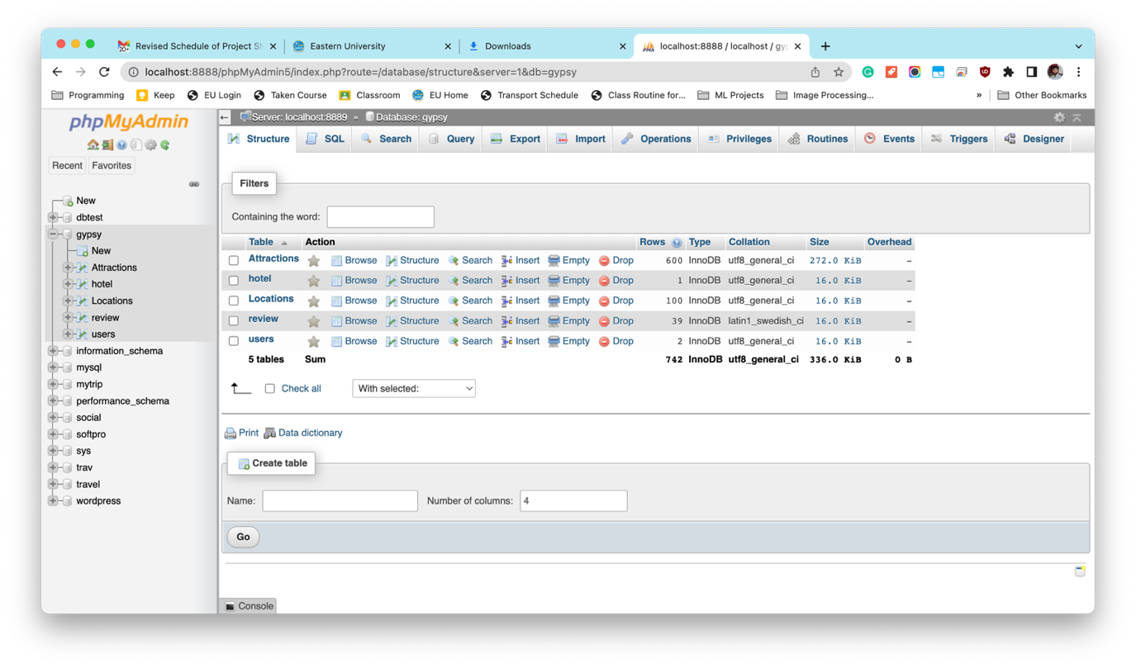

**Fig 5.2 Database Tables**

**5.3 Implementation of Front-end Design:**

In the context of the Travel Management System, front-end development refers to the user-facing aspect of the system, where users can directly interact with the interface. Our goal is to create a visually appealing, user-friendly front-end design that captures the attention of clients and keeps them engaged. To achieve this, we have utilized the following languages and frameworks for our front-end development:

**5.3.1 Language and Framework**

**HTML: HTML (Hypertext Markup Language)** serves as the fundamental building block of the Web, providing structure and meaning to web content. We have utilized HTML to establish the basic structure of our project.

**CSS: CSS (Cascading Style Sheets)** defines how HTML elements should be presented on various media, such as screens or paper. It enables us to customize the design and layout of our web pages.

**Bootstrap:** For streamlined and responsive development, we have incorporated Bootstrap, a free and open-source front-end framework. Specifically, we have implemented Bootstrap 5, which offers a range of predefined styles and components, facilitating the creation of responsive websites without extensive coding.

**JavaScript:** JavaScript, the widely adopted programming language of the Web, has been leveraged to incorporate logic and solve challenges within our project.

**5.4 Implementation of Back-end Development**

Back-end development involves working on the server-side software that handles the behind-the-scenes operations of a website, such as databases, back-end logic, APIs, architecture, and servers. Back-end developers are responsible for ensuring the proper functioning of the website.

In our project, we have utilized PHP for the back-end development. PHP is a widely used scripting language that is specifically designed for web development. It provides robust support for server-side functionality, making it ideal for handling complex tasks and interacting with databases.

By leveraging PHP, we have built the necessary infrastructure and implemented the logic required to ensure the smooth operation of our Travel Management System. The back-end development enables seamless communication between the front-end and the server, allowing users to interact with the system effectively.

**PHP**: A widely-used programming language for web applications, PHP is ideal for back-end development. It enables the creation of dynamic and interactive websites with its extensive features and community support.

**MySQL**: As a robust and reliable database management system, MySQL is seamlessly integrated with our project. It ensures efficient data storage and retrieval, enhancing the performance and functionality of our Travel Management System."

## 5.5 Snapshot of Front-end

## In our Travel Management System, we have captured snapshots of key front-end pages to showcase the visual design and user interface. Which is consists of various pages serving different purposes. We just add a few snap shot from the project. These pages include search functionalities, information provision, user and service provider registration, and dedicated sections for registered users. To provide a glimpse of our system's interface, we present snapshots of some key pages.

## 5.1.1 Home Page

## 

## Fig 5.1.1 Home Page

## 5.1.2 Login Page

## 

## Fig 5.1.2 Login Page

**Chapter 6**

**Conclusion and Future Works**

* 1. **Conclusion**

## In conclusion, the development of a comprehensive Travel Management System (TMS) aims to revolutionize travel planning and management in Bangladesh. By offering user-friendly interfaces, personalized recommendations, efficient booking and itinerary management, and robust administrative features, the TMS enhances the overall travel experience for individuals and organizations. Through the integration of advanced technologies and data analytics, it optimizes travel routes, provides real-time updates, and enables cost control. The implementation of the TMS contributes to the growth of the travel industry in Bangladesh, empowering users, improving efficiency, and fostering seamless travel experiences.

* 1. **Future Work**

1. The Travel Management System (TMS) project sets the foundation for future enhancements and advancements. Some potential areas for future work and development include:
2. Mobile Application: The development of a mobile application for the TMS would enable users to access and manage their travel plans on the go, providing convenience and flexibility.
3. Integration with Third-Party Services: Further integration with external services, such as airline reservation systems, hotel booking platforms, and transportation providers, would expand the range of options available to users and enhance the system's capabilities.
4. Enhanced Analytics and Reporting: Building advanced analytics and reporting functionalities would allow administrators to gain deeper insights into user behavior, travel trends, and system performance, enabling data-driven decision-making and continuous improvement.
5. Machine Learning and Artificial Intelligence: Leveraging machine learning and artificial intelligence algorithms can enhance personalized recommendations, optimize travel routes, and improve fraud detection and security measures.
6. Expansion to International Travel: Expanding the system to support international travel, including visa assistance, travel insurance, and country-specific information, would cater to the needs of travelers exploring destinations beyond Bangladesh.
7. Collaboration with Travel Service Providers: Strengthening partnerships with airlines, hotels, and other travel service providers can result in negotiated deals, exclusive offers, and a wider range of services for users.
8. These future enhancements aim to further enhance the functionality, efficiency, and user experience of the Travel Management System, ensuring it remains at the cutting edge of travel technology and meets the evolving needs of travelers.

**References**

[1] Travel Management System best practices

<https://navan.com/blog/a-guide-to-successfully-adopting-travel-management-software/>

[2] Agile software development methodologies in travel industry

<https://au.travelctm.com/blog/agile-technology/>

[3] Database implementation in travel management systems

<https://www.analyticsvidhya.com/blog/2021/07/beginners-guide-to-cloud-based-tourism-management-system/>

[4] Front-end development guideline

<https://cloudinary.com/guides/front-end-development/front-end-development-the-complete-guide/>

[5] Front-end development for travel websites

<https://www.aimprosoft.com/blog/how-to-build-a-travel-website/>

[5] Back-end development for travel management systems

<https://jazzteam.org/en/portfolio/backend-complex-travel-system/>

[5] Back-end development for travel management systems

<https://jazzteam.org/en/portfolio/backend-complex-travel-system/>

[6] Murat, Özkan. Agile Project Management in the Travel Industry. Master thesis, University of Oslo, URN: NBN:no-56453,2016